AUTOMATA THEORY AND COMPILER DESIGN

UNIT-1: Regular Expressions, Languages and Finite Automata
- Formal Languages and the Chomsky Hierarchy,
- Regular Expressions and Regular Languages,
- Algebraic Laws for Regular Expressions,
- Applications of Regular Expressions,
- Abstract model of Finite Automaton,
- Transition Tables and Transition Graphs,
- Deterministic Finite Automata (DFA),
- Nondeterministic Finite Automata (NFA),
- Converting NFA to DFA,
- Finite Automata with ε transitions (NFA-ε),
- Converting NFA-ε to NFA/DFA,
- Minimization of Finite Automata,
- Equivalence of FA and Regular Expressions

UNIT-1

AUTOMATA THEORY:
Automata Theory is a branch of the Theory of Computation. It deals with the study of abstract machines and their capacities for computation. It includes the design and analysis of automata, which are mathematical models that can perform computations on strings of symbols according to a set of rules.

Why we study Automata Theory?
- Regular Expressions (RE) : Used for pattern matching in Linux/Unix command prompt, programming languages and XML/DTD to describe structure.
- Finite Automata in Modeling Systems : Used in designing and checking models and electronic circuits that operate based on certain rules.
- Context-Free Grammars (CFG) : Used in Compiler / Programming Language design to describe syntax and natural language processing to describe structure.
- Mathematical Models : Mathematical understanding of computing devices by mathematically modeling them.
- Building Block for Quantam Computing: Turing Machines (we study in this subject) are considered a fundamental building block for understanding quantum computation models.
- Optimizing Algorithm Efficiency : Helps classify problems based (e.g., P, NP, NP-complete, and NP-hard), proving that some problems have no efficient solutions.
- Understanding Computability : Study of which problems can be solved using algorithms, essentially defining the boundaries of what a computer can calculate.. Problems like the "Halting Problem" which are demonstrably impossible to solve with a general algorithm.

COMPILER :
A compiler is software that translates or converts a program written in a high-level language (Source Language) into a low-level language (Machine Language or Assembly Language). Compiler design is the process of developing a compiler.
- It involves many stages like lexical analysis, syntax analysis (parsing), semantic analysis, code generation, optimization, etc.
- The Key objectives of compiler design are to automate the translation process, check correctness of input code, and reporting errors in source code.
- It acts as the "translator" of the programming world, bridging the gap between human-readable code and machine-understandable instructions.
- Most of the early high level languages like C and C++ were compiled. However modern languages like Java and Python use both interpreter and compiler. Please note that compiler only translates but interpreter runs as well.

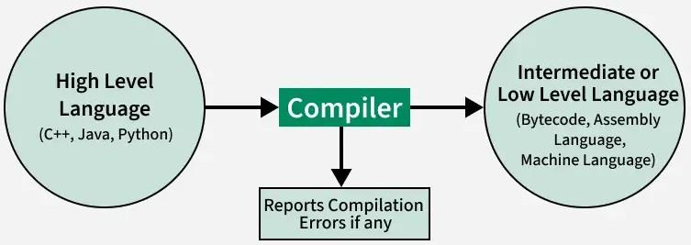

>What is the operations of compiler?
1. Analysing the Source Code
- The compiler reads and breaks the program into parts.
- It checks for errors in spelling, grammar (syntax), and meaning (semantics).
2. Understanding the Structure
- It understands the structure and logic of the program.
- It checks if variables are declared, used correctly, and if operations make sense.
3. Translating into Another Form
- The compiler translates the code into a middle form, which is easy to work with.
- Then it converts this into machine code (0s and 1s) step by step.
4. Improving the Code (Optional)
- It tries to optimize (improve) the code so that it runs faster and uses less memory.
5. Generating Output
- Finally, the compiler produces an executable file (like .exe in Windows), which you can run directly.

LANGUAGE PROCESSING SYSTEMS:
- We know a computer is a logical assembly of Software and Hardware. The hardware knows a language, that is hard for us to grasp, consequently, we tend to write programs in a high-level language, that is much less complicated for us to comprehend and maintain in our thoughts. Now, these programs go through a series of transformations so that they can readily be used by machines. This is where language procedure systems come in handy.
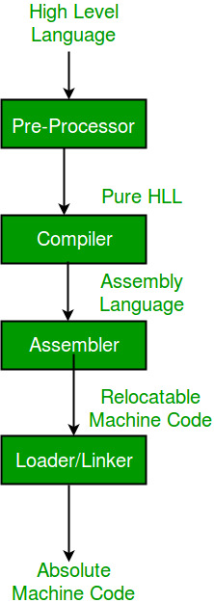
Fig: High-Level Language to Machine Code
- High-Level Language: If a program contains pre-processor directives such as #include or #define it is called HLL. They are closer to humans but far from machines. These (#) tags are called preprocessor directives. They direct the pre-processor about what to do.
- Pre-Processor: The pre-processor removes all the #include directives by including the files called file inclusion and all the #define directives using macro expansion. It performs file inclusion, augmentation, macro-processing, etc. For example: Let in the source program, it is written #include "Stdio. h". Pre-Processor replaces this file with its contents in the produced output.
- Assembly Language: It's neither in binary form nor high level. It is an intermediate state that is a combination of machine instructions and some other useful data needed for execution.
- Assembler: For every platform (Hardware + OS) we will have an assembler. They are not universal since for each platform we have one. The output of the assembler is called an object file. Its translates assembly language to machine code.
- Compiler: The compiler is an intelligent program as compared to an assembler. The compiler verifies all types of limits, ranges, errors, etc. Compiler program takes more time to run and it occupies a huge amount of memory space. The speed of the compiler is slower than other system software. It takes time because it enters through the program and then does the translation of the full program.
- Interpreter: An interpreter converts high-level language into low-level machine language, just like a compiler. But they are different in the way they read the input. The Compiler in one go reads the inputs, does the processing, and executes the source code whereas the interpreter does the same line by line. A compiler scans the entire program and translates it as a whole into machine code whereas an interpreter translates the program one statement at a time. Interpreted programs are usually slower concerning compiled ones.
- Relocatable Machine Code: It can be loaded at any point and can be run. The address within the program will be in such a way that it will cooperate with the program movement.
- Loader/Linker: Loader/Linker converts the relocatable code into absolute code and tries to run the program resulting in a running program or an error message (or sometimes both can happen). Linker loads a variety of object files into a single file to make it executable. Then loader loads it in memory and executes it.
  - Linker: The basic work of a linker is to merge object codes (that have not even been connected), produced by the compiler, assembler, standard library function, and operating system resources.
  - Loader: The codes generated by the compiler, assembler, and linker are generally re-located by their nature, which means to say, the starting location of these codes is not determined, which means they can be anywhere in the computer memory. Thus the basic task of loaders to find/calculate the exact address of these memory locations.
Overall, compiler design is a complex process that involves multiple stages and requires a deep understanding of both the programming language and the target platform. A well-designed compiler can greatly improve the efficiency and performance of software programs, making them more useful and valuable for users.

1.FORMAL LANGUAGES AND CHOMSKY HIERARCHY
In automata theory, languages and grammars are the most important concepts. Grammars are the most fundamental thing for human languages and computer languages as well.
The Language in Formal Language Theory A language can be defined as a set of strings over a given alphabet. This definition is true for human languages as well as computer languages. There are several components −
- Alphabet − A finite set of symbols
- String − A finite sequence of symbols from the alphabet
- Language − A (possibly infinite) set of strings over an alphabet
The Concept of Formal Languages
In computer science, we talk about the formal languages. This provides a rigorous framework for studying the properties and structures of languages. They are essential in computer science to make the syntax of programming languages and for analysing the capabilities of different computational models. Alphabets and strings are important components of formal languages.
Let us discuss about them a little:
- Alphabet (Σ) − A non-empty finite set of symbols
- String − A finite sequence of symbols from Σ
- Empty string (ε) − The string containing no symbols (This is important into formal languages)
- Length of a string − The number of symbols in the string
Formal languages can be classified into four types: regular, context-free, context-sensitive and recursively enumerable languages. But having a knowledge about languages is not enough; we need to go with grammars as well.
Grammars in Automata Theory
In automata, the grammars are formal systems for describing the structure of languages. In grammar, there are set of rules for generating valid strings in a language.
Formally, we can define grammar like this. A grammar is a tuple G = (V, Σ, P, S), where:
- V is a finite set of variables (non-terminal symbols)
- Σ is a finite set of terminal symbols (the alphabet)
- P is a finite set of production rules
- S is the start symbol (S ∈ V)
Grammars are used to generate all valid strings in a language, it also provides a structural description of the language and serve as a basis for parsing and syntax analysis. Let us see the following table to understand different components of a grammar clearly.

Component | Description | Example
Variables | Non-terminal symbols | A, B, C
Terminals | Symbols in the alphabet | a, b, c, 0, 1
Production rules | Rules for string generation | A → aB, B → bC
Start symbol | Initial variable for derivations | S

While we talk about grammars, it is necessary to understand two important concepts related to grammars –
- Derivation − A sequence of rule applications that transform the start symbol into a string of terminal symbols
- Parse tree − A graphical representation of a derivation, showing the hierarchical structure of the generated string
Let us understand them through an example:
Producing string "abc" from rules {S, S → aB, B → bC, C → c}
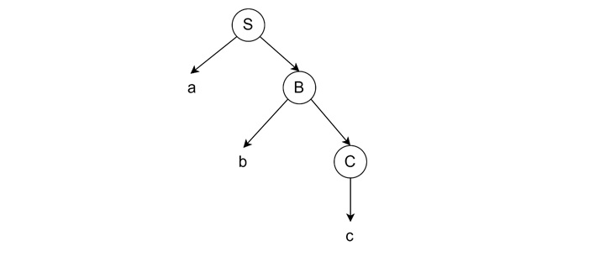
Applications of Languages and Grammars
The study of languages and grammars has many such practical applications in computer science and linguistics.
Field | Descriptions
Programming Languages | - Syntax − Formal grammars specify the structure of programming languages  - Parser generation − Grammars are used to automatically generate parsers for compilers  - Code analysis − Static analysis tools use grammars to understand program structure
Natural Language Processing | - Syntactic parsing − Grammars model the structure of human languages  - Machine translation − Formal language theory underpins translation algorithms  - Speech recognition − Language models based on grammars improve accuracy
Compiler Design | - Lexical analysis − Regular expressions (Type 3) define tokens  - Syntax analysis − Context-free grammars (Type 2) define language syntax  - Semantic analysis − Attribute grammars extend CFGs for semantic checks
Conclusion:
Languages and Grammars play an important role in Automata theory. In this chapter, we presented an overview on languages and grammars where we covered the basics of languages and more specifically formal languages.
Chomsky hierarchy:
- The Chomsky Hierarchy is a pivotal classification system conceived by the renowned linguist Noam Chomsky in the 1956.
- His classification delineated four types of grammars, each defining a different class of formal languages. These classes are now known as Type 0 (Unrestricted), Type 1 (Context-Sensitive), Type 2 (Context-Free), and Type 3 (Regular) grammars.

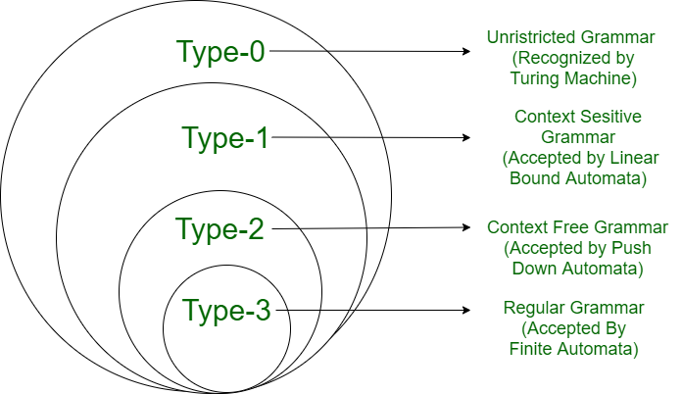
Type O:
- All formal grammars fall under type-0 grammars.
- The Turing machine can detect languages with type 0 grammar.
- The Recursively Enumerable languages are another name for these languages.
Type 0 Language Production in the form of α (alpha) to β (beta) where
- α is ( V + T)* V ( V + T)*
V = Non-terminals ,T = Terminals.
- β is ( V + T )*.
In type 0 there must be at least one variable on the Left side of production.
For example:
Sab -> ba
A -> S
Here, A, S are Non-terminals
and a, b are Terminals

Type 1:
- It is also known as Context Sensitive Language.
- It is recognized by the Linear Bound Automata.
According to the following rules, context-sensitive grammar:
- It should be Type 0
- Multiple symbols may be present on the left side of the production rules for the context-sensitive grammar.
- The number of symbols on the left side cannot be more than the number of symbols on the right side.
- The rule of the form A → ε is not allowed unless A is a start symbol. It does not occur on the right-hand side of any rule.
- In type 1, Production is in the form of |α| <= |β| Where the count of symbol in α is less than or equal to β.
- Also β ∈ (V + T)+ i.e. β can not be ε
For Example:
S -> AB
AB -> abc
B -> b

Type 2:
- It should be Type 1
- It is Context-Free Grammar (CFG)
- It is recognized by a Pushdown automata
- The left-hand side of production can have only one Non-terminal and there is no restriction on β (right side)
- The production rule is of the form |α| = 1.
For example:
S -> AB
A -> a
B -> b

Type 3:
- It should be Type 2
- It is a Regular Grammar
- It can be accepted by a finite-state automaton.
- It is the most restricted form of grammar.
- It can be described using regular expressions.
- These languages can be modelled by NFA or DFA.
It should be in the given form only :
V -> VT / T (left-regular grammar)
(or)
V -> TV /T (right-regular grammar)
For example:
S -> a
The above form is called strictly regular grammar.
There is another form of regular grammar called extended regular grammar. In this form:
V -> VT* / T* (extended left-regular grammar)
(or)
V -> T*V /T* (extended right-regular grammar)
For example :
S -> ab

Grammar | Languages | Recognizing automaton | Production rules (constraints)^{[a]} | Examples^{[5][6]}
Type-0 | Recursively enumerable | Turing machine | αβ (α non-empty) | L={w |w describes a terminating Turing machine }
Type-1 | Context-sensitive | Linear-bounded non-deterministic Turing machine | αAβαγβ | L={a^n b^n c^n |n>0}
Type-2 | Context-free | Non-deterministic pushdown automaton | Aα | L={ a^n b^n | n>0}
Type-3 | Regular | Finite-state automaton | Aa  AaB(right regular)  or  Aa  ABa (left regular) | L={a^n | n>0}
2. REGULAR EXPRESSIONS AND REGULAR LANGUAGES:
1.Regular Expressions:
Regular expressions are symbolic notations used to define search patterns in strings. They describe regular languages and are commonly used in tasks such as validation, searching, and parsing.
A regular expression represents a regular language if it follows these rules:
- ϵ (epsilon) is a regular expression representing the language {ϵ} (the empty string).
- Any symbol 'a' from the input alphabet Σ is a regular expression, representing the language {a}.
- Union (a + b) is a regular expression if a and b are regular expressions, representing the language {a, b}.
- Concatenation (ab) is a regular expression if a and b are regular expressions.
- Kleene star (a) is a regular expression*, meaning zero or more occurrences of 'a', forming a regular language.

Description | Regular Expression | Regular Languages
Ending with 01 | (0/1)*01 | {01,101,001,1001,1101,100101,….}
'a' followed by 0 or more 'b' | ab* | {a, ab, abb, abbb, abbbb, ...}
Any number of vowels followed by any number of consonants | [aeiou]*[bcdfghjklmnpqrstvwxyz]* | {ε, a, aou, aiou, b, abcd, ...} (ε represents empty string)

2.Regular Languages:
Regular languages are the class of languages that can be represented using finite automata, regular expressions, or regular grammar. These languages have predictable patterns and are computationally efficient to recognize.

Properties of Regular Languages
1. Closure Properties
Regular languages are closed under operations like union, concatenation, and Kleene star.
- Union: If L1 and If L2 are two regular languages, their union L1 +L2 will also be regular. For example, L1 = {an | n > 0} and L2 = {bn | n >0} L3 = L1 + L2 = {an ,bn | n > 0} is also regular.
- Concatenation: If L1 and If L2 are two regular languages, their concatenation L1.L2 will also be regular. For example, L1 = {an | n >0} and L2 = {bn | n >0} L3 = L1.L2 = {an. bn | n > 0} is also regular.
- Kleene Closure: If L1 is a regular language, its Kleene closure L1* will also be regular. For example, L1 = (ab) L1* = (ab)*
- Complement: If L(G) is regular language, its complement L’(G) will also be regular. Complement of a language can be found by subtracting strings which are in L(G) from all possible strings. For example, L(G) = {an | n > 3} L’(G) = {an | n <= 3}
2. Finite Automata:
- Every regular language can be recognized by a finite automaton (DFA or NFA).
3. Decision Problems:
- Problems like membership testing, emptiness, and equivalence can be solved for regular languages.
- Note: Two regular expressions are equivalent if languages generated by them are same. For example, (a+b*)* and (a+b)* generate same language. Every string which is generated by (a+b*)* is also generated by (a+b)* and vice versa.

3.Regular Grammar:
Regular grammars are widely used in computer science for lexical analysis, pattern matching, and text processing due to their efficiency and straightforward structure. Regular grammar is a formal grammar used to describe regular languages, which are the languages that can be recognized by finite automata. It serves as one of the simplest and most fundamental models in the Chomsky hierarchy of grammars. It is a type-3 class in Chomsky hierarchy.
A regular grammar is a formal grammar that generates regular languages. It consists of:
- Terminals: Symbols that form strings (e.g., a, b).
- Non-terminals: Variables used to derive strings (e.g., S, A).
- Production Rules: Rules for transforming non-terminals into terminals or other non-terminals.
- Start Symbol: The non-terminal from which derivations begin.
Types of Regular Grammar
- Right-linear Grammar(RLG): All production rules are of the form: A -> aB or A -> a.
Example:
S -> aS | bS | ε
- Left Linear Grammar(LLG):Left Linear Grammars are Special type of CFGs, where Each Production Rule has At Most 1 terminals on RHS & that Non-terminal is on Left Most position.
A ⇢ Bx
A ⇢ x
where A,B ∈ V and x ∈ T*

Aspect | Regular Expressions | Regular Grammar | Regular Languages
Definition | Pattern representation of strings | Rule-based generation of strings | Language class described by regex and grammar
Representation | Symbols and operators | Terminals, non-terminals, production rules | Finite automata, regex, or grammar
Use Case | Text processing, validation | Syntax generation for compilers | Language recognition

>>Conversions FA TO RLG LLG , RLG to FA, LLG TO FA :

1.Conversion of Finite Automaton (FA) to Right Linear Grammar (RLG) Left Linear Grammar (LLG)

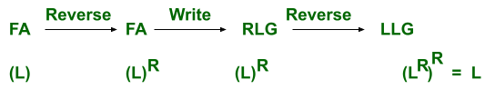
Fig: FA to LLG
For converting the FA to RLG into LLG for language L, the following procedure needs to be followed:
Step 1: Reverse the FA for language L
Step 2: Write the RLG for it.
Step 3: Reverse the right linear grammar.
after this we get the grammar that generates the language that represents the LLG for the same language L.

Example 1: FA for accepting strings that start with b
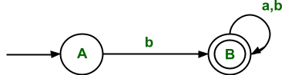
Fig: Finite Automata
∑ = {a, b}
Initial state(q0) = A
Final state(F) = B
The RLG corresponding to FA is
A ⇢ bB
B ⇢ ∈/aB/bB
The above grammar is RLG, which can be written directly through FA.
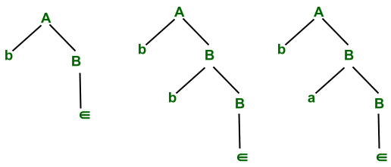
Fig: Parse Tree
The above RLG can derive strings that start with b and after that any input symbol (i.e. ∑ ={a, b} can be accepted).
The regular language corresponding to RLG is
L= {b, ba, bb, baa, bab, bba, bbb, ... }
If we reverse the above production of the above RLG, then we get LLG
A ⇢ Bb
B ⇢ ∈/Ba/Bb
It derives the language that contains all the strings which end with b.
i.e. L' = {b, bb, ab, aab, bab, abb, bbb, ...}

2.Conversion of Right Linear Grammar (RLG) to Finite Automaton (FA)
To convert a Right Linear Grammar (RLG) into its equivalent Finite Automaton (FA), follow the steps below:
Steps for Conversion:
- Start from the first production rule: Identify the start symbol (non-terminal) of the grammar. This becomes the start state of the FA.
- For each production rule, create transitions based on the structure:
If the production is of the form A → aB, draw a transition from state A to state B on input symbol a.
If the production is of the form A → a (i.e., no non-terminal follows the terminal), create a transition from state A to a final state on symbol a.
- Define the final state(F): Any state that appears in a rule of the form A → a or A → ε (i.e., ends with a terminal or empty string) becomes a final state in the FA.

3.Conversion of Left Linear Grammar (LLG) to Finite Automaton (FA)
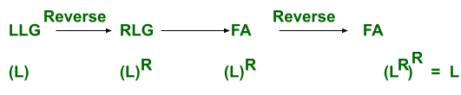
Fig: LLG to FA

- Convert the LLG to a Right Linear Grammar (RLG): Do this by reversing the strings in the productions (represents the reversed language L^R).
- Build an FA for the reversed language (L^R): Use the standard method: non-terminals become states, and transitions are based on the productions.
- Reverse the FA:
Reverse all transitions.
Make final states into start states and the original start state into the final state.
The resulting FA accepts the original language L.

Example:
1.The above grammar is taken which represents language L(i.e. set of all strings that start with b) The LLG for this grammar is
B ⇢ Ba/Bb/Ab
A ⇢ ∈
Ans: Step 1: Convert the LLG into FA (i.e. the conversion procedure is the same as above)
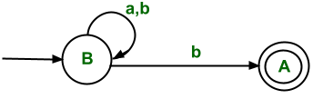
Step 2: Reverse the FA(i.e. initial state is converted into final state and convert final state to initial state and reverse all edges)
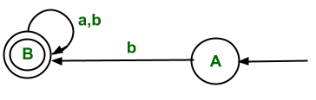
Step 3: Write RLG corresponding to reversed FA.
A ⇢ bB
B ⇢ aB/bB/∈
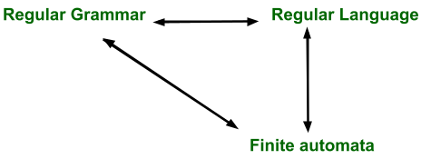

3.Algebraic Laws for Regular Expressions:
Regular expressions, often called regex or regexp, are a powerful tool used to search, match, and manipulate text. They are essentially patterns made up of characters and symbols that allow you to define a search pattern for text.
What is a Regular Expression?
Regular Expression is a Mathematical way of representing regular languages. The algebraic description for regular languages is done using regular expressions. They can define it in the same language that various forms of finite automata can describe. Regular expressions offer something that finite automata do not, i.e. it is a declarative way to express the strings that we want to accept.
Rules for Regular Expressions
- The set of regular expressions is defined by the following rules.
- Every letter of ∑ can be made into a regular expression, null string, ∈ itself is a regular expression.
If r1 and r2 are regular expressions, then (r1), r1.r2, r1+r2, r1*, r1 + are also regular expressions.
- Example - ∑ = {a, b} and r is a regular expression of language made using these symbols

Regular Expression | Regular Language
∅ | { }
∈ | {∈}
a* | {∈, a, aa, aaa .....}
a+ b | {a, b}
a.b | {ab}
a* + ba | {∈, a, aa, aaa,...... , ba}
Operations Performed on Regular Expressions
1. Union
The union of two regular languages, L1 and L2, which are represented using L1 ∪ L2, is also regular and which represents the set of strings that are either in L1 or L2 or both.
Example:
L1 = (1+0).(1+0) = {00 , 10, 11, 01} and
L2 = {∈ , 100}
then L1 ∪ L2 = {∈, 00, 10, 11, 01, 100}.
2. Concatenation
The concatenation of two regular languages, L1 and L2, which are represented using L1.L2 is also regular and which represents the set of strings that are formed by taking any string in L1 concatenating it with any string in L2.
Example:
L1 = { 0,1 } and L2 = { 00, 11} then L1.L2 = {000, 011, 100, 111}.
3. Kleene closure
If L1 is a regular language, then the Kleene closure i.e. L1* of L1 is also regular and represents the set of those strings which are formed by taking a number of strings from L1 and the same string can be repeated any number of times and concatenating those strings.
Example:
L1 = { 0,1} = {∈, 0, 1, 00, 01, 10, 11 .......} , then L* is all strings possible with symbols 0 and 1 including a null string.

Algebraic Properties of Regular Expressions:
If r1 and r2 are regular expressions(RE), then
- r1* is a RE
- r1+r2 is a RE
- r1.r2 is a RE

1.Commutative Property:
If r1, r2 are RE, then
- r1+r2 = r2+r1. For example, for r1 =a and r2 =b, then RE a+ b and b+ a are equal.
- r1.r2 ≠ r2.r1. For example, for r1 = a and r2 = b, then RE a.b is not equal to b.a.

2. Associativity Property:
If r1, r2, r3 are RE, then
i.) r1+ (r2+r3) = (r1+r2) +r3
- For example : r1 = a , r2 = b , r3 = c, then
- The resultant regular expression in LHS becomes a+(b+ c) and the regular set for the corresponding RE is {a, b, c}.
- for the RE in RHS becomes (a+ b) + c and the regular set for this RE is {a, b, c}, which is same in both cases. Therefore, the associativity property holds for union operator.
ii.) r1.(r2.r3) = (r1.r2).r3
- For example - r1 = a , r2 = b , r3 = c
- Then the string accepted by RE a.(b.c) is only abc.
- The string accepted by RE in RHS is (a.b).c is only abc ,which is same in both cases. Therefore, the associativity property holds for concatenation operator.
Associativity property does not hold for Kleene closure(*) because it is unary operator.

3.Identity Property:
In the case of union operators,
r + ∅ = ∅ + r = r,
Therefore, ∅ is the identity element for a union operator.
In the case of concatenation operator:
r.x = r , for x= ∈, r.∈ = r
Therefore, ∈ is the identity element for concatenation operator(.).

4. Annihilator Property:
- If r+ x = r ⇒ r ∪ x= x , there is no annihilator for +
- In the case of a concatenation operator, r.x = x, when x = ∅, then r.∅ = ∅, therefore ∅ is the annihilator for the (.)operator.
- For example {a, aa, ab}.{ } = { }

5. Distributed Property:
If r1, r2, r3 are regular expressions, then
- (r1+r2).r3 = r1.r3 + r2.r3 i.e. Right distribution
- r1.(r2+ r3) = r1.r2 + r1.r3 i.e. left distribution
- (r1.r2) +r3 ≠ (r1+r3)(r2+r3)
6.Idempotent Law:
- r1 + r1 = r1 ⇒ r1 ∪ r1 = r1 , therefore the union operator satisfies idempotent property.
- r.r ≠ r ⇒ concatenation operator does not satisfy idempotent property.

7. Closure Laws:
- (r*)* = r*, closing an expression that is already closed does not change the language.
- ∅* = ∈, a string formed by concatenating any number of copies of an empty string is empty itself.
- r + = r.r* = r*r, as r* = ∈ + r + rr+ rrr .... and r.r* = r+ rr + rrr ......
- r* = r*+ ∈

8.Identities for Regular Expression
There are many identities for the regular expression. Let p, q and r are regular expressions.
- ∅ + r = r
- ∅.r= r.∅ = ∅
- ∈.r = r.∈ =r
- ∈* = ∈ and ∅* = ∈
- r + r = r
- r*.r* = r*
- r.r* = r*.r = r + .
- (r*)* = r*
- ∈ +r.r* = r* = ∈ + r.r*
- (p.q)*.p = p.(q.p)*
- (p + q)* = (p*.q*)* = (p* + q*)*
- (p+ q).r= p.r+ q.r and r.(p+q) = r.p + r.q

4. Applications of Regular Expressions:
Test Search and Manipulation
Lexical analyzer

Input validation

Data extraction and parsing
Command-line operations
Application of Regular Expression

Network security
Programming and code parsing
Web development

1. Text Search and Manipulation:
Regular expressions (regex) are very powerful tools for finding, modifying, and extracting patterns in text.
Example 1: Find all mobile numbers (10 digits)
Regex: \b\d{10}\b Matches: 9876543210, 8123456789
Example 2: Find all words that start with "a"
Regex: \ba\w* Matches: apple, amazing, activity
- Text Manipulation (Substitution or Editing)
You can replace, remove, or reformat matching text.
Example 1: Replace all digits with #
Regex: \d Replace with: # Input: My number is 12345 Output: My number is #####
Example 2: Remove all extra spaces
Regex: + Replace with: (a single space) Input: This is a test Output: This is a test
2. Input Validation:
- Use: To check if input follows a specific format.
- Examples:
  - Email validation: ^[a-zA-Z0-9_.+-]+@[a-zA-Z0-9-]+\.[a-zA-Z0-9-.]+$
  - Phone number validation: ^\d{10}$
3. Data Extraction and Parsing:
- Use: Extract or clean data from raw text or HTML pages.
- Example: Extract all <title> tags from HTML using <title>(.*?)</title>
4. Programming and Code Parsing:
Regular expressions are widely used in programming and code parsing for analyzing and transforming source code, detecting patterns, extracting tokens, and more.
5. Web Development:
- Use: Validate user input (like password rules).
- Example: Password with 1 uppercase, 1 digit: ^(?=.*[A-Z])(?=.*\d).{8,}$
6. Network Security:
- Use: Prevent injection attacks by filtering unwanted inputs.
- Example: Reject SQL keywords like SELECT, DROP using a regex filter.
7. Command-Line Operations:
- Use: Validate user input (like password rules).
- Example: Password with 1 uppercase, 1 digit: ^(?=.*[A-Z])(?=.*\d).{8,}$
8. Lexical Analysis (Compiler Design):
- Use: Break source code into tokens like identifiers, keywords, literals.
- Example: Match identifiers
Regex: [a-zA-Z_][a-zA-Z0-9_]*
Matches: main, sum_1, MyClass
conclusion, regular expressions stand as a versatile and indispensable tool in the realm of text processing and beyond. Their ability to define and match patterns has led to widespread adoption in diverse fields, from programming to web development, data analysis, network security. As technology continues to advance, the importance of regular expressions is likely to persist, playing a vital role in shaping the landscape of text processing and pattern matching.
5.Abstract model of Finite Automaton:

A algorithm or program that automatically recognizes if a particular string belongs to the language or not, by checking the grammar of the string. An automata is an abstract computing device (or machine). There are different varities of such abstract machines (also called models of computation) which can be defined mathematically.
- A Finite Automaton (FA) is a mathematical model of computation used to recognize regular languages. It consists of a finite number of states, and it processes an input string symbol by symbol, transitioning between states according to a transition function.

Components of finite automata:

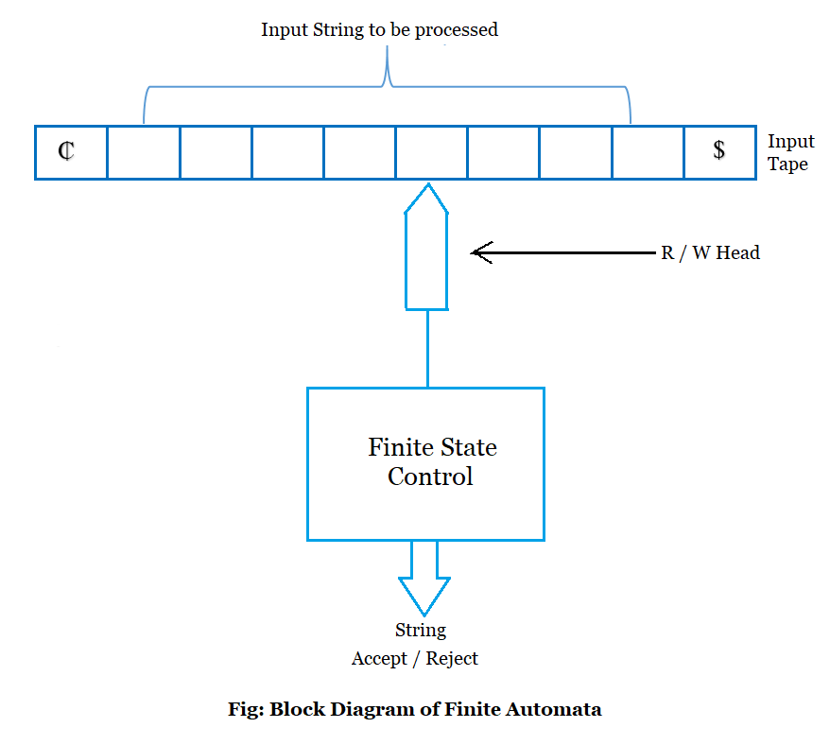
1.Input tape
2.R/W head
3.Finite state control
4.Accept/Reject

Input Tape
- The horizontal strip at the top is the Input Tape.
- It contains the input string to be processed by the automaton.
- The string is usually surrounded by special symbols:
  - ¢ → Start symbol
  - $ → End symbol
- Each box in the tape holds a single input symbol (e.g., 0 or 1).

2. Read/Write Head (R / W Head)
- The arrow pointing to the input tape is the Read/Write head.
- It reads one symbol at a time from left to right.
- In Finite Automata (unlike Turing Machines), this head is read-only and moves only right (in DFA/NFA).

3. Finite State Control
- This is the main processing unit.
- It represents the logic and set of rules (states and transitions).
- Based on the symbol read by the head and the current state, it transitions to a new state using the transition function δ.
4. Accept / Reject Output
- After processing the full string, the automaton ends in a state.
- If that state is an accepting (final) state, the string is Accepted.
- Otherwise, it is Rejected.

✅ How It Works (Flow Summary):
- The input string is placed on the tape between ¢ and $.
- The head reads the first symbol after ¢.
- The Finite State Control decides the next state using the transition function.
- The head moves right, reads the next symbol, and the process repeats.
- After reading all symbols, if the current state is a final state, the string is accepted; else, it is rejected.

🧠 Key Point:
- This model is mostly used for DFA (Deterministic Finite Automata) and NFA (Nondeterministic Finite Automata).
- It represents how automata simulate reading strings in formal language theory.
Elements of Finite automata:
A finite automata is an abstract machine used to model computation. It consists of a finite number of states and operates on input symbols to transition between these states based on a set of rules.
To represent the finite automata, we need 5 tuples −
M=(Q,Σ,δ,q0,F)
where −
- Q − A finite, non-empty set of states.
- Σ − A finite, non-empty set of input alphabets (symbols).
- δ − The transition function, which maps into .
- q0 − The initial state, which is an element of .
- F − A subset of representing the set of final states.
- States (Q) − Q is a finite, non-empty set of states. Each state represents a unique condition or configuration of the system.
- Input Alphabets (Σ) − Σ is the finite, non-empty set of input symbols that the automaton reads to determine state transitions.
- Transition Function (δ) − δ is a set of functions that defines how the automaton transitions from one state to another based on the current state and input symbol. It can be expressed as: δ:Q×Σ→Q.
- Initial State (q0) − q0 is the initial state from which the automaton starts its computation. It belongs to the set.
- Final States (F) − F is a subset of containing one or more final states. These states signify the acceptance of the input string by the automaton.

Example:
Let’s design a Deterministic Finite Automaton (DFA) that accepts all binary strings ending with 01.
A. L={01,101,001,1101,1001,10001,……}
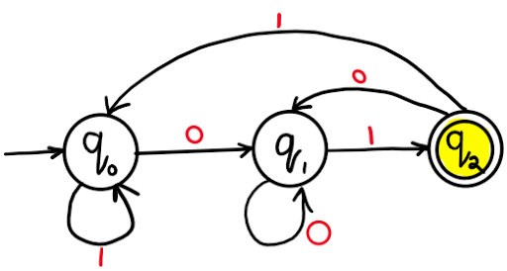
🔹 Alphabet (Σ): Σ={0,1}
🔹 Set of States (Q): Q={q0,q1,q2}
🔹 Start State: q0={ q0}
🔹 Final (Accepting) State: F={q2}
🔹 Transition Function (δ):
Δ(q₀,0)q1
Δ(q₀,1)q0
Δ(q1,0)q1
Δ(q1,1)q2
Δ(q2,0)q1
Δ(q2,1)q0

6.Transition Tables and Transition Graphs:
Transition graphs and transition tables are used to depict a DFA.
Transition graphs
Transition graph can be interpreted as a flowchart for an algorithm recognizing a language. A transition graph consists of three things:
- A finite set of states, at least one of which is designated the start state and some of which are designated as final states.
- An alphabet Σ of possible input symbols from which the input strings are formed.
- A finite set of transitions that show the change of state from the given state on a given input.
A successful path through the transition graph is a series of edges forming a path beginning at the start state and ending at one of the final states.

The transition graph in the figure represents a DFA with at least one a and at least one b.
A transition diagram for DFA, M = ( Q, Σ, δ, F, q₀) is a graph defined as follows:
(a) For each state in Q there is a node represented by the circle.
(b) For each state q in Q each input symbol a in Σ, let δ(q, a) = q’. Then transition diagram has an arc from q to q’, labelled a.
(c) There is always an arrow into the start state that is not from any other state.
(d) Nodes corresponding to accepting states are denoted by a double circle. Rest of the states are depicted by a single circle.
Some of the transition graphs are given below
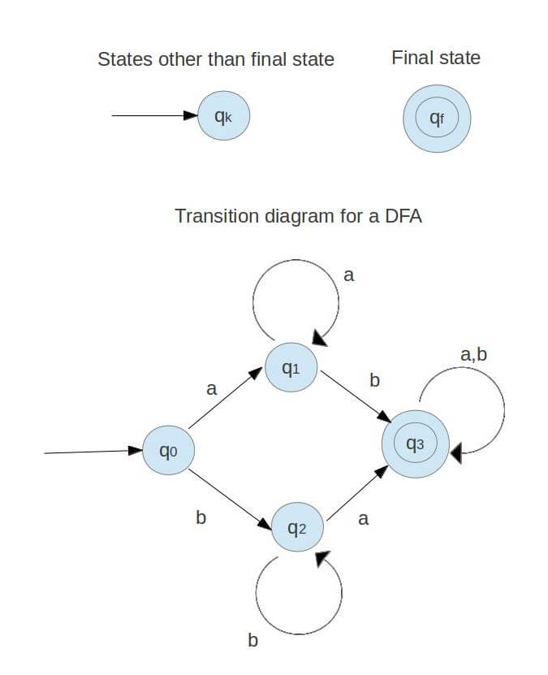
Fig: Transition graph
Transition tables:
A transition table is a tabular representation of the transition function that takes two arguments and returns a state. The column contains the state in which the automaton will be on the input represented by that column. The row corresponds to the state the finite control unit can be in. The entry for one row corresponding to state q and the column corresponds to input a is the state δ(q, a).
For the transition graph in the above figure the transition table would be as follows:

States/Input symbols | a | b
q₀ | q₁ | q₂
q₁ | q₁ | q₃
q₂ | q₂ | q₃
*q₃ | q₃ | q₃

7.Deterministic Finite Automata (DFA):

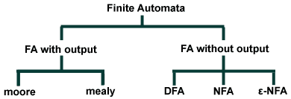

Fig: Finite automata types
Deterministic Finite Automata (DFA)
- DFA refers to deterministic finite automata. Deterministic refers to the uniqueness of the computation. The finite automata are deterministic FA, if the machine reads an input string one symbol at a time.
- In DFA, there is only one path input from the current state to the next state. It does not accept the null move, i.e. it cannot change state without any input. It can contain multiple final states. It is used in Lexical Analysis in compilers.
Finite Automaton can be classified into two types −
- Deterministic Finite Automaton (DFA)
- Non-deterministic Finite Automaton (NDFA / NFA)
>Deterministic Finite Automaton (DFA)
A Deterministic Finite automata (DFA) is a collection of defined as a 5-tuples and is as follows − DFA (Deterministic finite automata)
- DFA refers to deterministic finite automata. Deterministic refers to the uniqueness of the computation. The finite automata are called deterministic finite automata if the machine is read an input string one symbol at a time.
- In DFA, there is only one path for specific input from the current state to the next state.
- DFA does not accept the null move, i.e., the DFA cannot change state without any input character.
- DFA can contain multiple final states. It is used in Lexical Analysis in Compiler.
In the following diagram, we can see that from state q0 for input a, there is only one path which is going to q1. Similarly, from q0, there is only one path for input b going to q2.
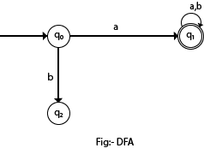
Formal Definition of DFA
M=(Q,Σ,δ,q0,F)
Where,
- Q is a finite set of states.
- ∑ is a finite set of symbols called the alphabet.
- δ is the transition function where δ: Q × ∑ → Q
- q₀ is the initial state from where any input is processed (q₀ ∈ Q).
- F is a set of final state/states of Q (F ⊆ Q).
Graphical Representation of a DFA
A DFA is represented by digraphs called state diagram.
- The vertices represent the states.
- The arcs labeled with an input alphabet show the transitions.
- The initial state is denoted by an empty single incoming arc.
- The final state is indicated by double circles.
Conditions to construct DFA
- first condition says that the machine starts in the start state q₀.
- The second condition says that given each character of string w, the machine will transition from state to state according to the transition function δ.
- The last condition says that the machine accepts w if the last input of w causes the machine to halt in one of the accepting states. Otherwise, it is said that the automaton rejects the string. The set of strings that M accepts is the language recognized by M and this language is denoted by L(M).

>>Problems on DFA:
Example 1: Draw a DFA for the language accepting strings ending with ‘0’ over input alphabets ∑={0, 1} ?
- Solution:
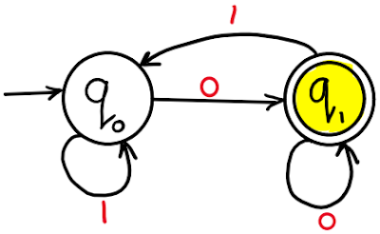
Example 2: Draw a DFA for the language accepting strings ending with ‘01’ over input alphabets ∑={0, 1} ?
- Solution:
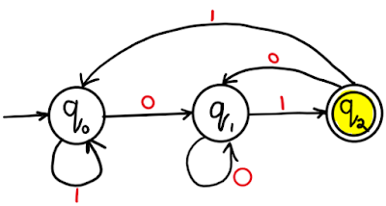

Example 3: Draw a DFA for the language accepting strings ending with ‘00’ over input alphabets ∑={0, 1} ?
- Solution:
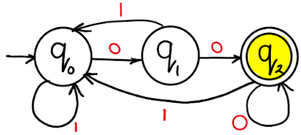

Example 4: Draw a DFA for the language accepting strings ending with ‘011’ over input alphabets ∑ = {0, 1} ?
- Solution:
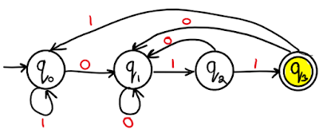

Example 5: Draw a DFA for the language accepting strings ending with ‘0110’ over input alphabets ∑ = {0, 1} ?
- Solution:
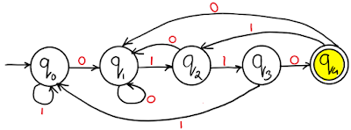
Example 6: Draw a DFA for the language accepting strings ending with ‘0011’ over input alphabets ∑ = {0, 1} ?
- Solution:
- 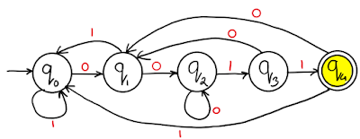

Example 7: Draw a DFA for the language accepting strings with ‘0’ only over input alphabets ∑={0, 1} ?
- Solution:
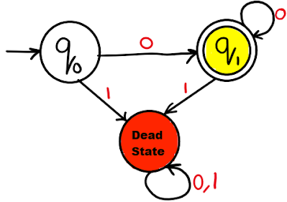

Example 8: Draw a DFA for the language accepting strings with ‘0’ and ‘1’ only over input alphabets ∑={0, 1} ?
- Solution:
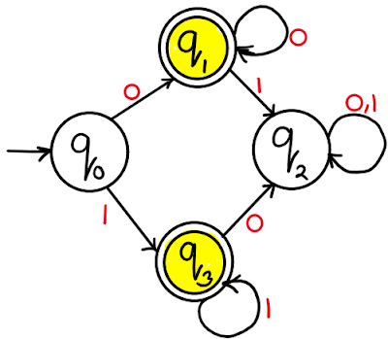

Example 9: Draw a DFA for the language accepting strings starting with ‘0’ over input alphabets ∑={0, 1} ?
- Solution:
- 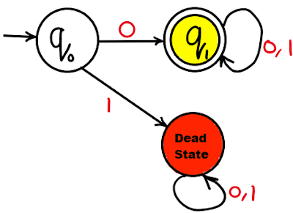

Example 10: Draw a DFA for the language accepting strings starting with ‘01’ over input alphabets ∑={0, 1} ?
- Solution:
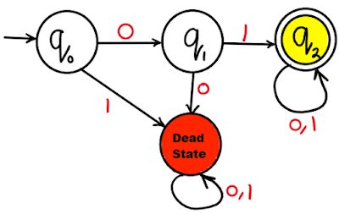
Example 11: Draw a DFA for the language accepting strings without substring ‘00’ over input alphabets ∑ = {0, 1} ?
- Solution:
- 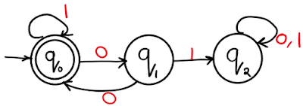
Example 12: Draw a DFA for the language accepting even binary numbers strings over input alphabets ∑ = {0, 1} ?
- Solution:
- 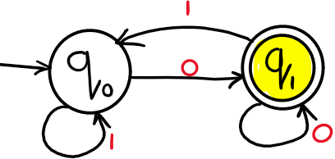

Example 13: Draw a DFA for the language accepting odd binary numbers strings over input alphabets ∑ = {0, 1} ?
- Solution:
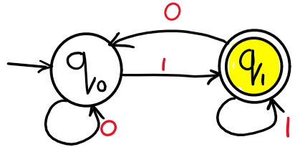

Example 14: Draw a DFA for the language accepting odd or even binary numbers strings over input alphabets ∑ = {0, 1} ?
- Solution:
